**TASK -5**

**Q1: write a program to reverse a given string**

**PROGRAM**

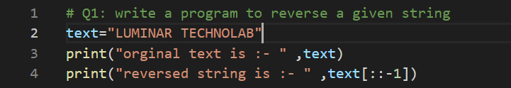

**OUTPUT**



**Q2: write a program in python to print the characters present at even index and odd index separately for the given string**

**PROGRAM**

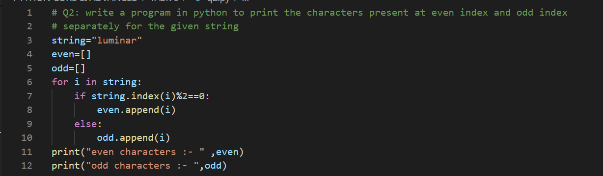**OUTPUT**



**Q3: program to merge string alternately using python**

**example :**

**input:"major","general"**

**output: mgaejnoerral**

**PROGRAM**

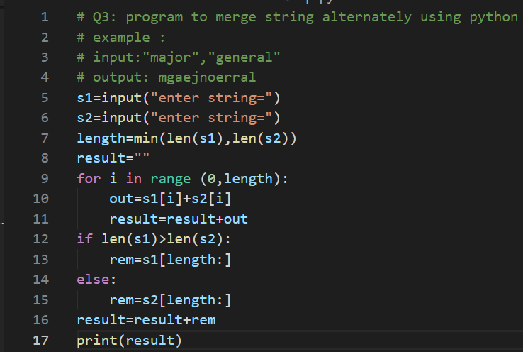

**OUTPUT**

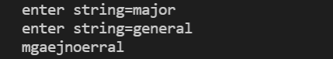

**Q4: program to sort characters of the strings, first symbol followed by digits**

**example:**

**input: a2b4c6**

**output: abc246**

**PROGRAM**

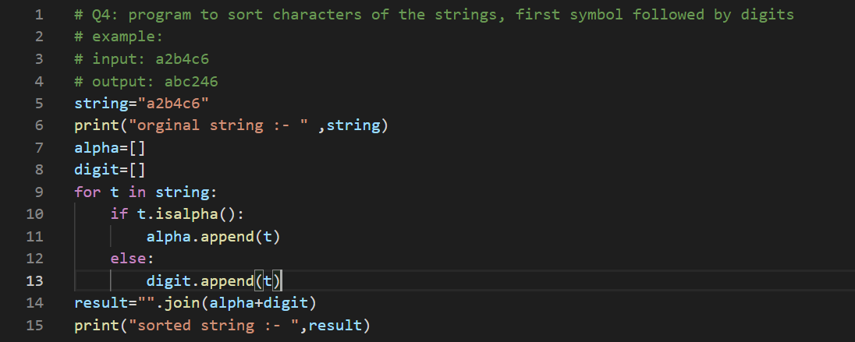

**OUTPUT**



**Q5: program to find the number of occurrences of each vowel present in the given string**

**PROGRAM**

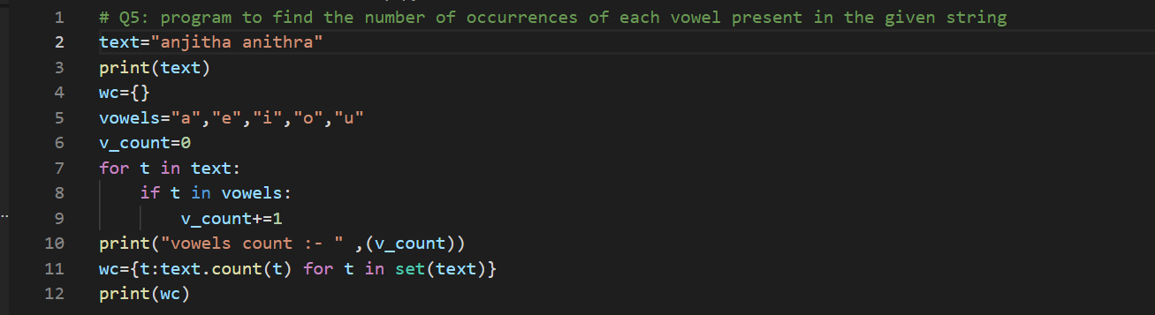

**OUTPUT**

